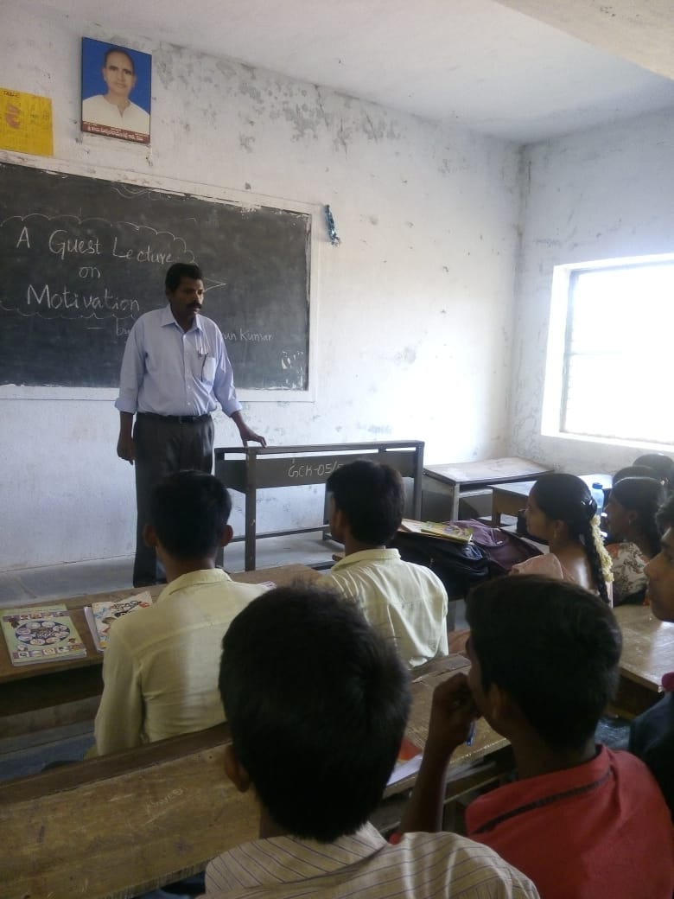

Guest Lecture on

Motivation by Mr. S.John Arun Kumar P.G Teacher in English

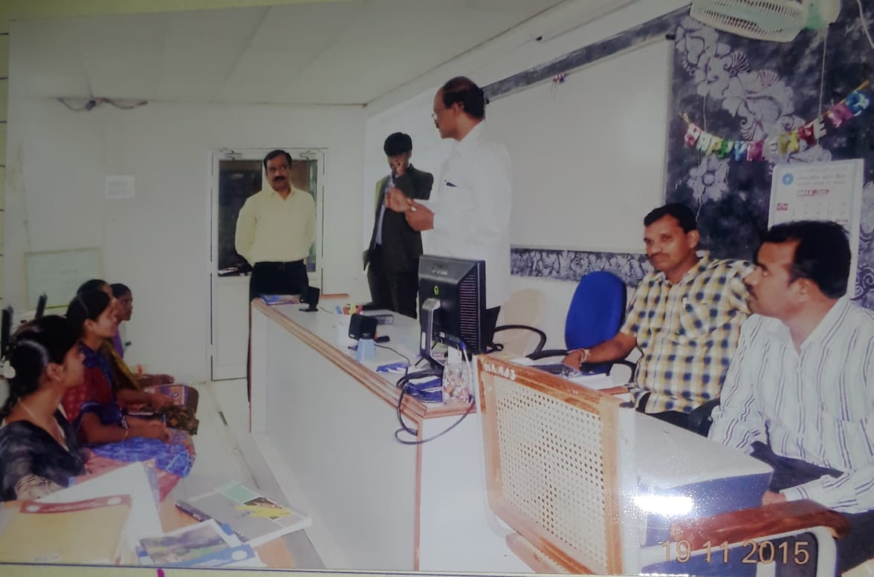

Former Principal of our college speaking on student development before introducing Mr. K. Giri Prasad Reddy, A Professional Psychologist

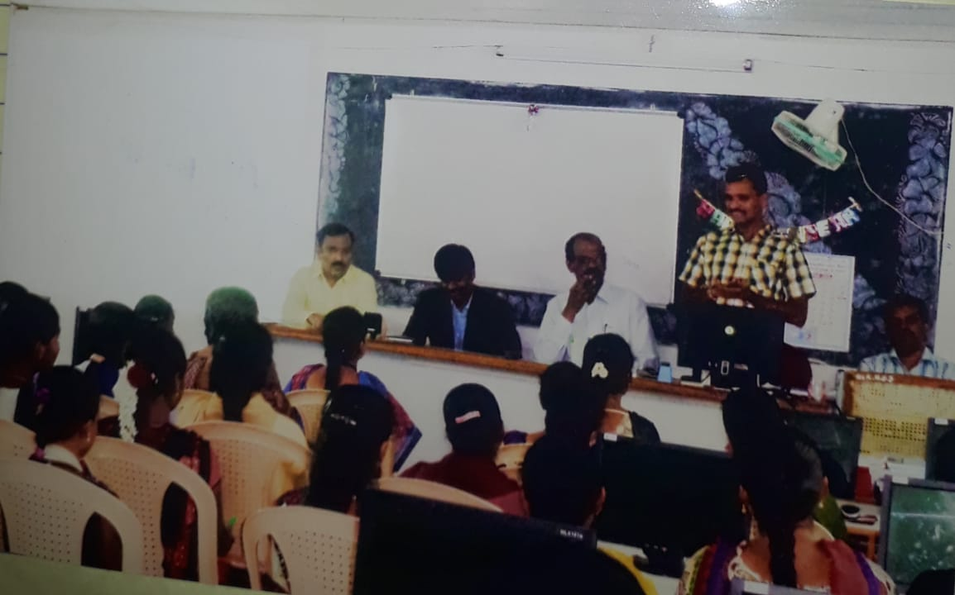

Mr. K. Giri Prasad Reddy, A Professional Psychologist, delivering a Guest Lecture on Personality Enrichment

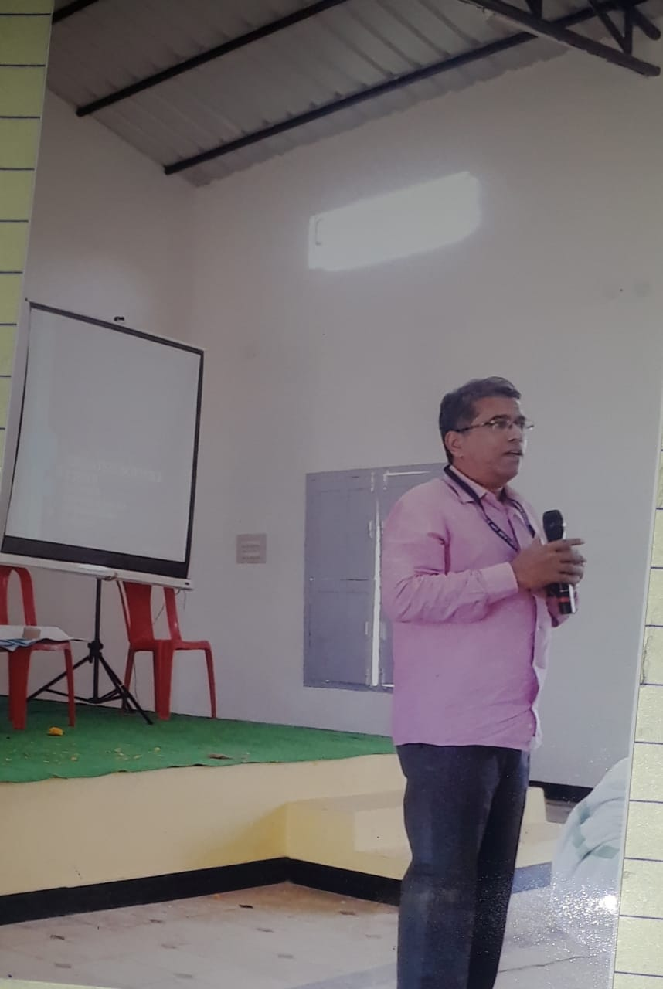

A Guest lecture on Soft Skills by Dr. Pvs Prasad, Asst. Prof. of Zoology, Govt.College(Men), Anantapuramu.

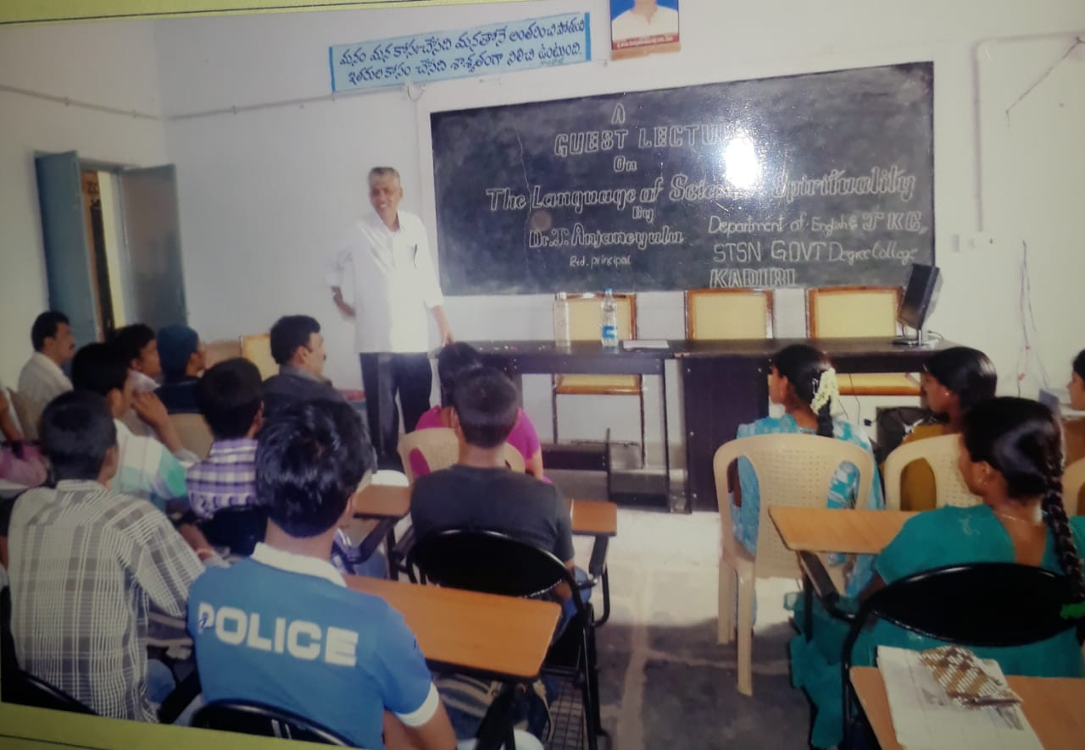 A Guest lecture on Science and Spirituality by Dr. Anjaneyulu, former Principal of STSN GDC, Kadiri.

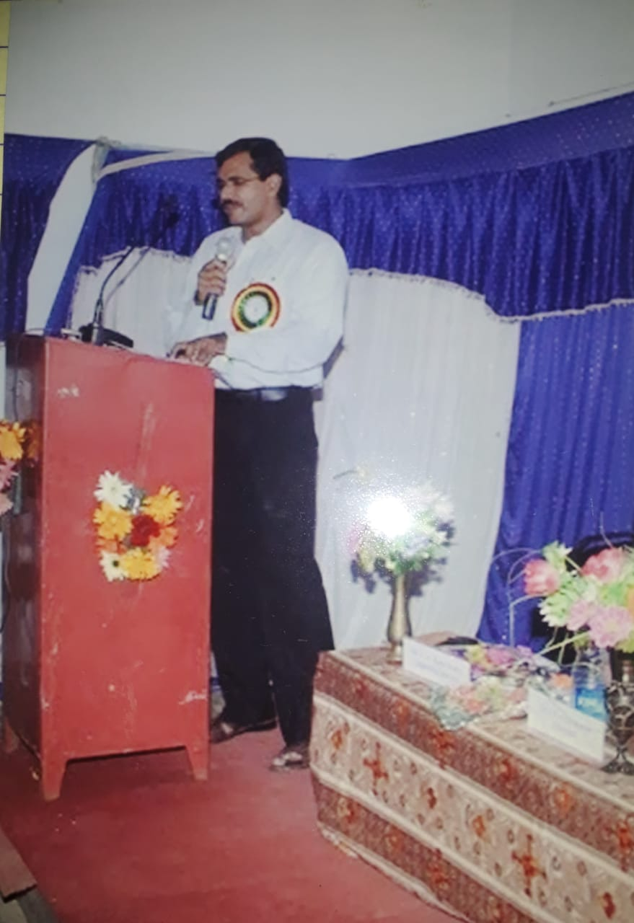

Dr. V. Srirama Murthy, Asst. Prof. of English addressing the students on Remedial English

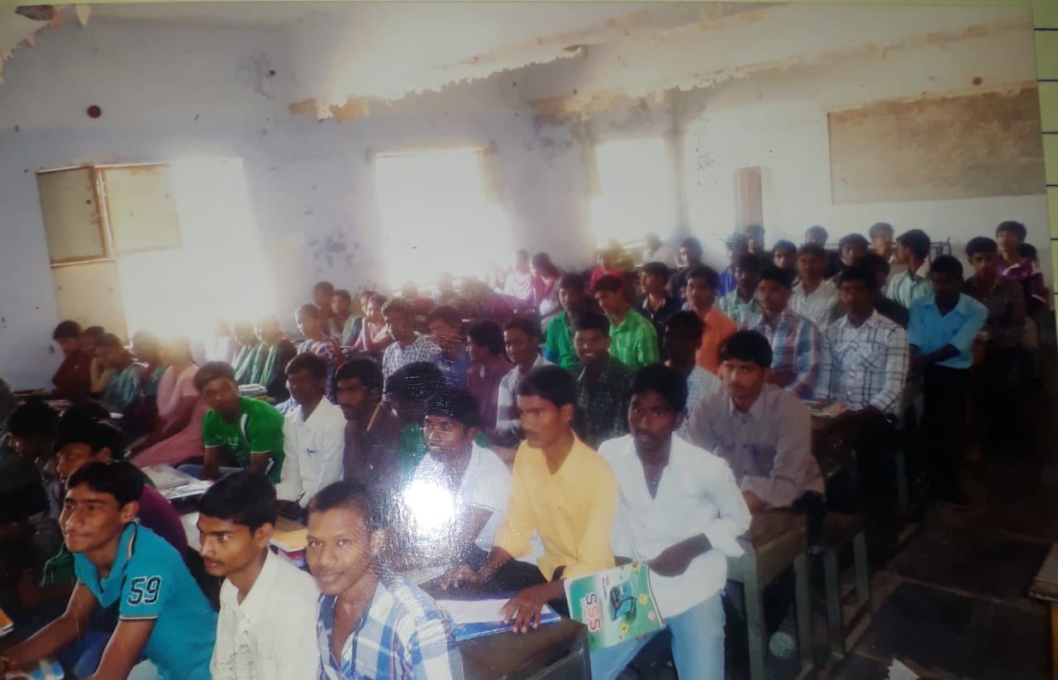

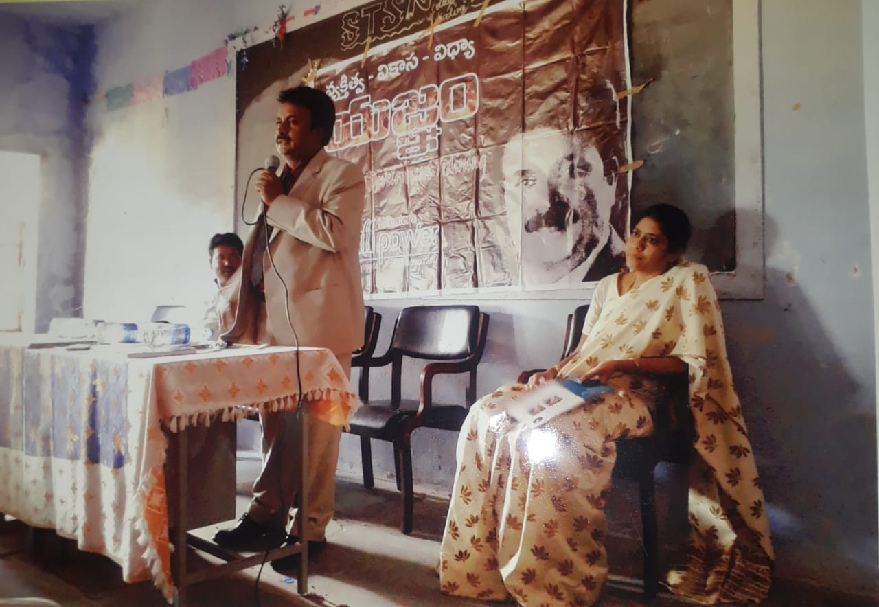

A Guest lecture on Vyakthithva Vikasa Vidya Yagnam by Creative Krishna

Seminar on

Importance of Communication Skills in English

